D

DLD-Quiz#3

By:   
  
Name:   
Abdul-Rehman  
Roll.no:  
19l-1135  
Section:   
CS-D1

| Q0 | Q1 | Q2 | Q3 |  | Q0+ | Q1+ | Q2+ | Q3+ |  | T0 | T1 | T2 | T3 |
| --- | --- | --- | --- | --- | --- | --- | --- | --- | --- | --- | --- | --- | --- |
| 0 | 0 | 0 | 0 |  | 0 | 0 | 0 | 1 |  | 0 | 0 | 0 | 1 |
| 0 | 0 | 0 | 1 |  | 0 | 0 | 1 | 0 |  | 0 | 0 | 1 | 1 |
| 0 | 0 | 1 | 0 |  | 0 | 0 | 1 | 1 |  | 0 | 0 | 0 | 1 |
| 0 | 0 | 1 | 1 |  | 0 | 1 | 0 | 0 |  | 0 | 1 | 1 | 1 |
| 0 | 1 | 0 | 0 |  | 0 | 1 | 0 | 1 |  | 0 | 0 | 0 | 1 |
| 0 | 1 | 0 | 1 |  | 0 | 1 | 1 | 0 |  | 0 | 0 | 1 | 1 |
| 0 | 1 | 1 | 0 |  | 0 | 1 | 1 | 1 |  | 0 | 0 | 0 | 1 |
| 0 | 1 | 1 | 1 |  | 1 | 0 | 0 | 0 |  | 1 | 1 | 1 | 1 |
| 1 | 0 | 0 | 0 |  | 1 | 0 | 0 | 1 |  | 0 | 0 | 0 | 1 |
| 1 | 0 | 0 | 1 |  | 0 | 0 | 0 | 0 |  | 1 | 0 | 0 | 1 |

**Q  
(a)  
  
  
(b)  
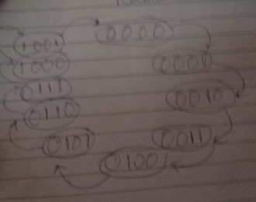  
THANK YOU**